The numbers in this sequence increase by 75 each time.  Write the two missing numbers.  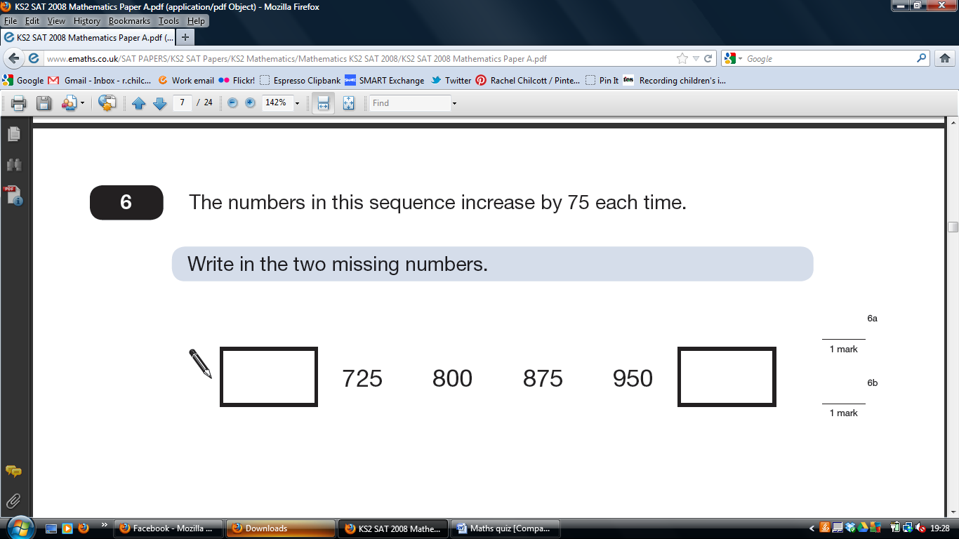 | A square always has four sides.  Is it true that a four-sided shape is always a square? | Grange School collects money for three charities. This pictogram shows how much they have collected.  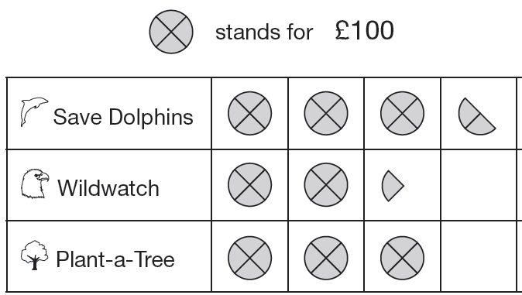  How much more have they collected for Save Dolphins than Wildwatch? | Calculate 239 + 689

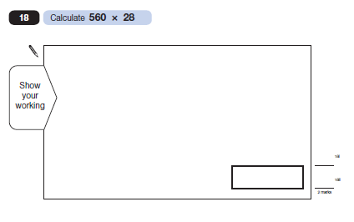
Top Tip : Remember to always show your working – you might get an extra mark.

Put these times in order, starting with the shortest.  6 minutes  24 seconds  1 minute  112 seconds | On a sheet of stickers there are 5 circles, 2 stars and one rectangle.  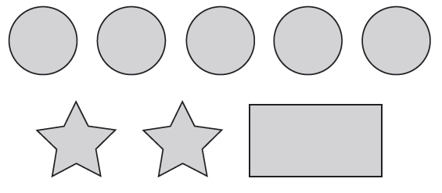  Rameen needs 45 circles.  How many sheets of stickers does she need? | Match each question to the correct answer.  7 x 5 35  Half of 98 50  Double 5 x 5 44  49 | The target for Wildwatch is £600.  How much more money do they need to collect for Wildwatch?
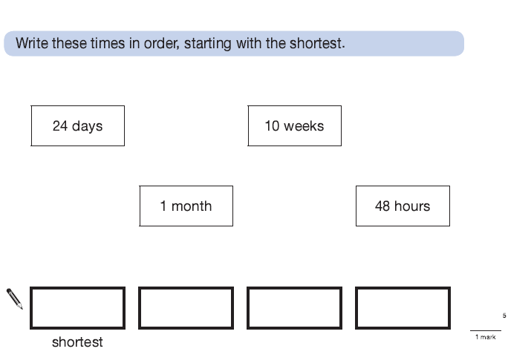
Top Tip: Always check that you have answered the question. Make sure you work out ‘how much change’ or ‘start with the shortest.’

On a sheet of stickers there are 5 circles, 2 stars and one rectangle.  John has 10 sheets of stickers.  How many more circles than rectangles does he have? | Here is a number chart.  Circle the smallest number on the chart that is a multiple of both 2 and 7.  71 72 73 74 75 76 77 78 79 80 81 82 83 84 85 86 87 88 89 90 91 92 93 94 95 96 97 98 99 100 | Circle the largest number that is not a multiple of 2 or 3 or 5.  71 72 73 74 75 76 77 78 79 80 81 82 83 84 85 86 87 88 89 90 91 92 93 94 95 96 97 98 99 100 | 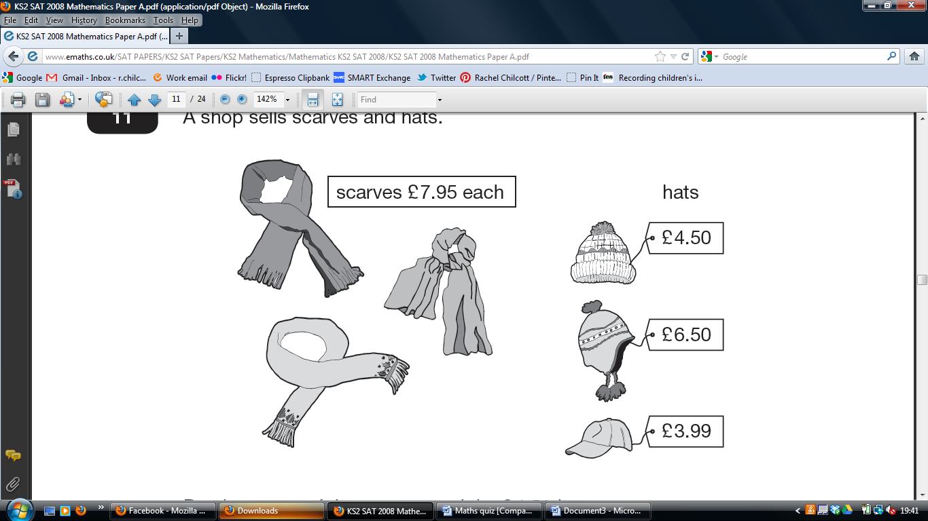  Ben buys one of the scarves and the £4.50 hat.  How much change does he get from £20?

Top Tip: If you get stuck while revising… take a short break, come back to the problem and then try again.

Draw the reflection of the shaded shape in the mirror line

Calculate 364 ÷ 7 | 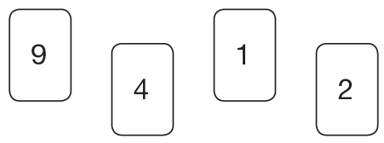  Use each digit card once to make the decimal number nearest to 20.  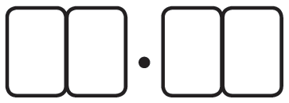 | This regular 12-sided shape has a number at each vertex.  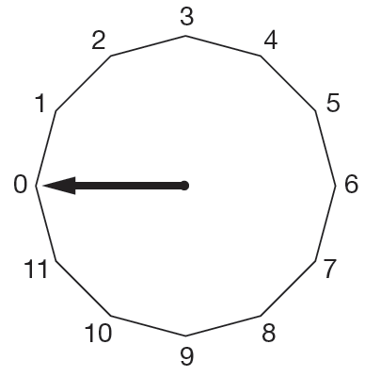  Ben turns the pointer from zero, clockwise through 150°  Which number will the pointer now be at? | Ben thinks of a number.  He adds half of the number to a quarter of the number.  The result is 60  What was the number Ben first thought of?

Top Tip: Choose a place to revise where you won’t be distracted.

Emily has 6 cubes. She sticks them together to make this model.  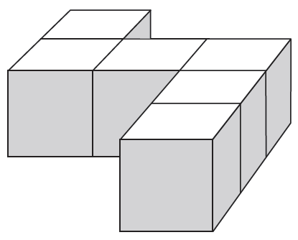  She paints the sides of the model grey all the way round.  She leaves the top and the bottom of the model white.  How many of the cubes in the model have exactly two faces  painted grey? | 1/3 of this square is shaded.  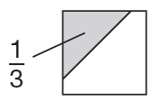  The same square is used in the diagrams below.  What fraction of this diagram is shaded?  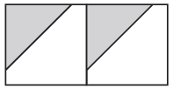 | Calculate 45.3 × 6 | The numbers in this sequence increase by 7 each time.  1 8 15 22 29 ....  The sequence continues in the same way.  Will the number 777 be in the sequence?

Top Tip: Get plenty of sleep and relax ! zzzzzz, don’t worry !

Nisha’s kettle holds 2 litres of water.  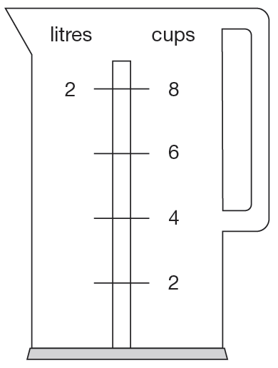  How many millilitres are equal to 1 cup? | 1/3 of this square is shaded.  What fraction of this diagram is shaded?  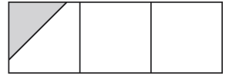 | Emily makes 250 grams of a snack mixture.  15% of the weight is raisins, 25% is banana chips and  the rest is peanuts.  How many grams of peanuts does she use? | 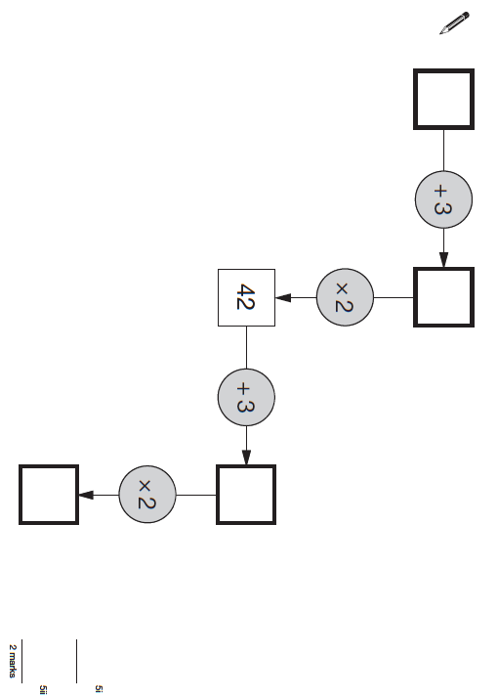  Fill in the missing numbers

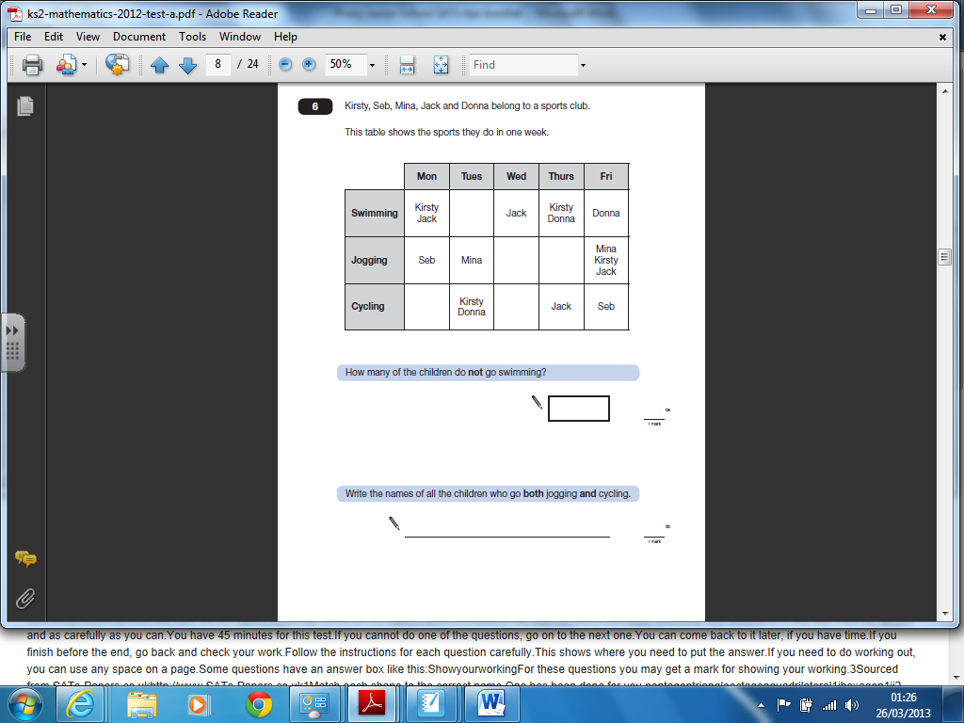
Top Tip: With some word problems you may need two answers – part a) and part b). Make sure you work through the question a bit at a time, taking care to read and check your answer.

 | These are all times on the same morning:  - 7.56am  - Quarter to eight  - Six minutes to eight  - Half past seven  Write the letters for the times in order, starting with the earliest. | Multiples of 2  Multiples of 4  Here is a Venn diagram for sorting numbers.  Write each number in the correct place on the diagram.  10 11 12 13 | Write these in order, starting with the smallest.  $\frac{3}{4}$ 0.34 0.7 43%
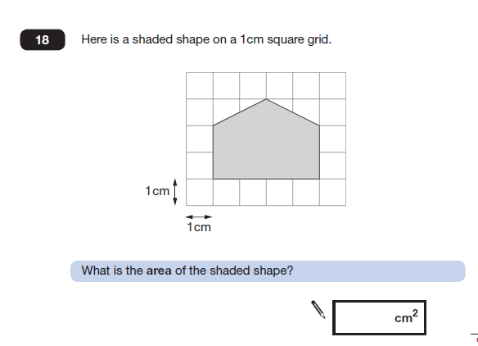

Top Tip: Write any additional information that you need. Don’t worry about drawing extra grid lines, adding a column or crossing off numbers as you use them.

Dev has 5 coins.  He has £1.60 altogether.  Write down what each of the coins could be. |  | Holly takes half an hour to walk to school.  She arrives at school at 8.25am.  What time did she leave home? | 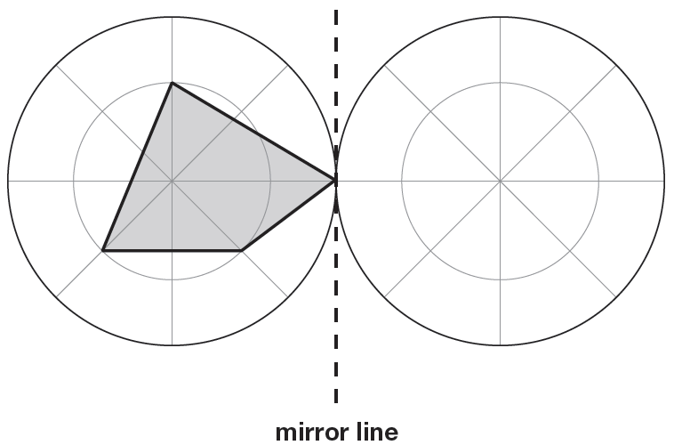  Draw the reflection.

Top Tip: Remember a fraction means ‘out of,’

$\frac{3}{8}$ means 3 parts out of 8 parts

$\frac{5}{\text{16}}$ means 5 parts out of 16 parts

